ISM TECHNICAL SPECIFICATION DOCUMENT

MML (Minera Media Luna)

Torex Gold

MML TECHNICAL SPECIFICATION

v.1.2

March 10, 2025

**Document Control**

Owner: Colin Jessop <Colin.Jessop@kyndryl.com>

Requested By: Rohit Tellis <Rohit.Tellis@torexgold.com>

Authors: Krishna kishore dabula ([krishna.kishore.dabula@kyndryl.com](mailto:krishna.kishore.dabula@kyndryl.com), [krishna.kishore.dabula@torexgold.com](mailto:krishna.kishore.dabula@torexgold.com)

Revision History

|  |  |  |  |
| --- | --- | --- | --- |
| **Date** | **Revision** | **Description** | **Author** |
| Feb 12 2025 | 1.0 | Initial Draft with Dev & Prod environments | KK |
| Mar 07 2025 | 1.0 | Review comments | Arpita |
| Mar 10 2025 | 1.2 | Review comments | KK |
|  |  |  |  |
|  |  |  |  |

**Table of Contents**

1 Introduction 4

1.1 Purpose of this document 4

1.2 MML Scope 4

1.3 MML Out of Scope 4

2 Azure and Fabric – MML (Minera Media Luna) 5

2.1 Data Mapping Overview 5

2.2 Fabric configuration Overview 6

2.3 Data Mapping Details 9

2.2.11 ActualTopoDB1 Source File 9

2.2.12 ML - Longhole Drilling DB Source File 11

2.2.13 Ore Control Media Luna Source File 14

2.2.14 PlanMonthDB Source Excel File 18

2.2.15 PlanYearDB Source Excel File 22

2.2.16 Equipment Availability Source SQL Function 26

2.2.17 Equipment Source SQL Table 29

2.2.18 Enum Table Source SQL Table 34

2.2.19 Calendar Dimension 35

2.4 Assumptions 38

2.5 Key Success Criteria - for the MML solution 38

2.6 MML Scripts and Queries 38

2.7 MML test plan and test cases 39

2.8 MML Deployment : 39

3 Approvals 40

4 Appendices 40

4.1 Annex 1: Data Architecture 40

4.2 Annex 2: DWH-End to End Implementation: 41

# Introduction

This document outlines the requirements for the Torex Gold MML project (Minera Media Luna), which aims to enhance the data warehouse capabilities by integrating various data sources (Excel files and Microsoft SQL Server) for providing comprehensive reporting solutions for MML (reporting is out of the scope).

## Purpose of this document

The purpose of this document is to detail the technical specification for MML data model structure in the bronze, silver and gold layers of the new Torex Gold Microsoft Azure and Fabric based data warehouse as well as the scheduling and load type details for the same. This document is to be used to assist on the development and implementation of the Fabric MML solution. This includes the mapping of source data to target tables, transformation logic, and scheduling options.

## MML Scope

The project involves the following key components:

* Integration of data from multiple sources into a centralized data warehouse – data sources: 5 Excel files and 3 tables Microsoft SQL Server (1 Fact + 2 dimensions).
* Implementation of transformation logic to ensure data consistency and accuracy.
* Development of two semantic models that support the data structure within the warehouse (one semantic model for all 5 Excel files and another semantic model for all 3 SQL Server tables).

## MML Out of Scope

* Report(s) development is out of scope.

# Azure and Fabric – MML (Minera Media Luna)

## Data Mapping Overview

The following tables provide an overview of the data mapping from source to target tables:

1. 5 Excel files:

| **Source File Name** | **Staging Table Name** | **Target Table Name** | **Table Description** |
| --- | --- | --- | --- |
| ActualTopoDB1.xlsx | stg_actual_topo | fact_actual_topo | Contains the Fact details, including the raw data of advanced meters that are surveyed - square meters of material that has been advanced – further comments under “ActualTopoDB1 Source File” section. |
| ML - Longhole Drilling DB.xlsx | stg_longhole_drilling | fact_longhole_drilling | Contains the Fact details for Production drilling, including the raw data of drilled meters mined – further comments under “ML - Longhole Drilling DB Source File” section. |
| Ore Control Media Luna.xlsm | stg_ore_control_medialuna | fact_ore_control_medialuna | Records the origin, date, and location of minerals, including the type of material and daily production of lateral developments and stopes – further comments under “Ore Control Media Luna Source File” section. |
| PlanMonthDB.xlsx | stg_plan_month | fact_plan_month | Records the forecast data (Monthly), measuring the meters and tonnes, and other metrics for assessing the quality and economic viability of the ore being mined – further comments under “PlanMonthDB Source File” section. |
| PlanYearDB.xlsx | stg_plan_year | fact_plan_year | Records the annual budget data, including the date, location, and type of minerals (e.g., gold, silver, copper). It categorizes materials as waste or ore, providing essential details for budget planning – further comments under “PlanYearDB Source File” section. |

1. 3 SQL Tables (1 function + 2 tables):

| **Source Table Name** | **Staging Table Name** | **Target Table Name** | **Table Description** |
| --- | --- | --- | --- |
| [BI].[Equipment Availability] | stg_equipment_availability | fact_equipment_availability | This is to measure Daily the equipment Availability and Utilization for Fleet = 'UNDERGROUND' on MML (Media Luna Mining). |
| [dbo].[equipment] | stg_equipment | dim_equipment | This table contains the details of Equipment associated with every fact_ equipment_availability - in a Star schema. |
| [dbo].[enum_tables] | stg_enum | dim_enum | This table contains Parameters information (for Equipment and other subjects) associated with every fact_  equipment_availability - in a Star schema. |
| N/A | N/A | dim_calendar | Date table associated with every Fact - in a Star schema. |

**MML Mapping document :**



## Fabric configuration Overview

The following is an overview of the technical configuration in fabric

**Workspace Names:**

**Click on workspace and create workspace as below.**

**Lake house Names:**

**Click on lakehouse and create new lakehouse**

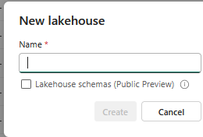

**Warehouse Name:**

**Click on warehouse and create new warehouse**

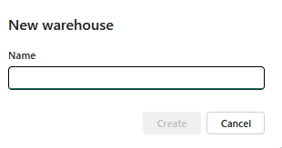

**](https://app.fabric.microsoft.com/groups/c6b23ee3-fa7f-4528-a989-143b70cfec15/datawarehouses/f9090848-c31b-4852-92e8-09c4432421d0?experience=data-engineering)

## Data Mapping Details

### ActualTopoDB1 Source File

#### **Source/target Information:**

* **Source File Name:** ActualTopoDB1.xlsx
* **Source File Location :** https://torexgold.sharepoint.com/sites/MediaLunaProject/Technical Services/05_Survey/ActualTopoDB1.xlsx
* **Staging Table Name (Silver Layer):** stg_actual_topo
* **Target Table Name (Gold Layer):** fact_actual_topo

#### **Table Description:**

This table contains the Fact details, including the raw data of advanced meters that are surveyed. The process involves surveying to measure the volume (in square meters) of material that has been moved or advanced, tracking the development progress in the Topography and Planning operation.

#### **Key Information:**

* **Pipeline Name:** [pl_actual_topo](https://app.fabric.microsoft.com/groups/225ef3c4-f1f6-4c57-87b5-b2a8216e7d46/pipelines/a9a72a07-70f8-4c4f-a060-4cd5dbfa6ecc?experience=data-engineering&subfolderId=21279)  : To load into fact_actual_topo
* **Stage Pipeline Name:** [pl_stage_ActualTopoDB](https://app.fabric.microsoft.com/groups/225ef3c4-f1f6-4c57-87b5-b2a8216e7d46/pipelines/8246ebe7-9d96-4a7f-99fd-a7e61755dc9d?experience=data-engineering&subfolderId=21279)  To load into stg_actual_topo
* **Data flow Name:**  [dfg2_mml_brz_ActualTopoDB](https://app.fabric.microsoft.com/groups/225ef3c4-f1f6-4c57-87b5-b2a8216e7d46/pipelines/a9a72a07-70f8-4c4f-a060-4cd5dbfa6ecc?experience=data-engineering&subfolderId=21279)

#### **Scheduling Options:**

* **Frequency:** Twice a day (10am EST & 10pm EST)
* **Reprocessing & load Logic:** Based on the "fecha" field, it should reprocess Month to Date + Previous Month (M + M-1).
* **Load type:** Delete and Insert. **Note:** The historical data is required to be maintained (do not delete the historical records). The “Delete” is for the purpose of reprocessing, it requires to delete ONLY the Month to Date + Previous Month (M + M-1) period (previous/historical data should not be touched – deleted or changed).

#### **Field-Level Descriptions and Transformations – Gold Layer:**

* **actual_topo_sk:**
  + **Target Field Name:** actual_topo_sk
  + **Target Datatype:** BIGINT
  + **Transformation Logic:** Surrogate key, serving as the primary key for the table. A sequential or unique value is generated for each record during data insertion.
* **fecha_sk:**
  + **Target Field Name:** fecha_sk
  + **Target Datatype:** INT
  + **Transformation Logic:** Foreign key fetched from the dim_calendar table. The date format follows the pattern YYYYMMDD (e.g., 20241007).
* **lineage_sk:**
  + **Target Field Name:** lineage_sk
  + **Target Datatype:** INT
  + **Transformation Logic:** Foreign key retrieved from the log_lineage table to track run history.
* **fecha:**
  + **Target Field Name:** fecha
  + **Target Datatype:** DATE
  + **Transformation Logic:** Conversion applied to DATE.
* **nombre:**
  + **Target Field Name:** nombre
  + **Target Datatype:** VARCHAR(50)
  + **Transformation Logic:** Field remains unchanged from source to target.
* **tipo_actividad:**
  + **Target Field Name:** tipo_actividad
  + **Target Datatype:** VARCHAR(25)
  + **Transformation Logic:** Field remains unchanged from source to target.
* **levantamiento:**
  + **Target Field Name:** levantamiento
  + **Target Datatype:** VARCHAR(9)
  + **Transformation Logic:** Field remains unchanged from source to target.
* **avance:**
  + **Target Field Name:** avance
  + **Target Datatype:** DECIMAL(6,3)
  + **Transformation Logic:** Field remains unchanged from source to target.

### ML - Longhole Drilling DB Source File

#### **Source/target Information:**

* **Source File Name:** ML - Longhole Drilling DB.xlsx
* **Source File Location :** https://torexgold.sharepoint.com/sites/MediaLunaProject/Technical Services/08_Reportes/01_Pruebas_BD/ML - Longhole Drilling DB.xlsx
* **Staging Table Name (Silver Layer):** stg_longhole_drilling
* **Target Table Name (Gold Layer):** fact_longhole_drilling

#### **Table Description:**

This table contains fact details for **Production Drilling (Barrenación de Producción)**, including the raw data of drilled meters. The process involves capturing the length of meters drilled for production purposes.

#### **Key Information:**

* **Main Pipeline Name:** [pl_longhole_drilling](https://app.fabric.microsoft.com/groups/225ef3c4-f1f6-4c57-87b5-b2a8216e7d46/pipelines/9be6416e-f513-48c3-a679-11523aa78640?experience=data-engineering&subfolderId=21885)  to load into fact_longhole_drilling
* **stage Pipeline Name:** [pl_stage_LongholeDrilling](https://app.fabric.microsoft.com/groups/225ef3c4-f1f6-4c57-87b5-b2a8216e7d46/pipelines/4df59528-3098-4fc6-80d6-f88428c6e1ec?experience=data-engineering&subfolderId=21885) to load into stg_longhole_drilling
* **data flow Name:**  [dfg2_mml_brz_ML_Longhole_Drilling](https://app.fabric.microsoft.com/groups/225ef3c4-f1f6-4c57-87b5-b2a8216e7d46/pipelines/9be6416e-f513-48c3-a679-11523aa78640?experience=data-engineering&subfolderId=21885)

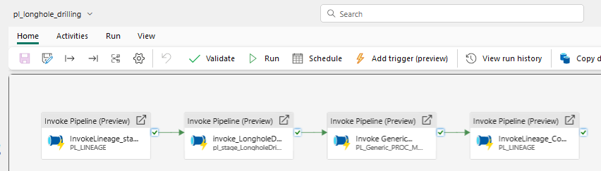

#### **Scheduling Options:**

* **Frequency:** Twice a day (10am EST & 10pm EST)
* **Reprocessing & load Logic:** Based on the "fecha" field, it should reprocess Month to Date + Previous Month (M + M-1).
* **Load type:** Delete and Insert. **Note:** The historical data is required to be maintained (do not delete the historical records). The “Delete” is for the purpose of reprocessing, it requires to delete ONLY the Month to Date + Previous Month (M + M-1) period (previous/historical data should not be touched – deleted or changed).

#### **Field-Level Descriptions and Transformations – Gold Layer:**

* **longhole_drilling_sk:**
  + **Target Field Name:** longhole_drilling_sk
  + **Target Datatype:** BIGINT
  + **Transformation Logic:** Surrogate key, serving as the primary key for the table. A sequential or unique value is generated for each record during data insertion.
* **fecha_sk:**
  + **Target Field Name:** fecha_sk
  + **Target Datatype:** INT
  + **Transformation Logic:** Foreign key fetched from the dim_calendar table. The date format follows the pattern YYYYMMDD (e.g., 20241007).
* **lineage_sk:**
  + **Target Field Name:** lineage_sk
  + **Target Datatype:** INT
  + **Transformation Logic:** Foreign key retrieved from the log_lineage table to track run history.
* **fecha:**
  + **Target Field Name:** fecha
  + **Target Datatype:** DATE
  + **Transformation Logic:** Conversion applied to DATE.
* **turno:**
  + **Target Field Name:** turno
  + **Target Datatype:** INT
  + **Transformation Logic:** Field remains unchanged from source to target.
* **zona:**
  + **Target Field Name:** zona
  + **Target Datatype:** VARCHAR(4)
  + **Transformation Logic:** Field remains unchanged from source to target.
* **zona_1:**
  + **Target Field Name:** zona_1
  + **Target Datatype:** VARCHAR(15)
  + **Transformation Logic:** Field remains unchanged from source to target.
* **equipo:**
  + **Target Field Name:** equipo
  + **Target Datatype:** VARCHAR(15)
  + **Transformation Logic:** Field remains unchanged from source to target.
* **gasto:**
  + **Target Field Name:** gasto
  + **Target Datatype:** VARCHAR(5)
  + **Transformation Logic:** Field remains unchanged from source to target.
* **longitud:**
  + **Target Field Name:** longitud
  + **Target Datatype:** DECIMAL(8,4)
  + **Transformation Logic:** Field remains unchanged from source to target.
* **lr: (lugar)**
  + **Target Field Name:** lr => (*) There was a mismatch in the provided file and the source file. We updated this field from “lugar” to “lr” to match the source file.
  + **Target Datatype:** VARCHAR(50)
  + **Transformation Logic:** Field remains unchanged from source to target.
* **tipo:**
  + **Target Field Name:** tipo
  + **Target Datatype:** VARCHAR(20)
  + **Transformation Logic:** Field remains unchanged from source to target.
* **comentarios:**
  + **Target Field Name:** comentarios
  + **Target Datatype:** VARCHAR(255)
  + **Transformation Logic:** Field remains unchanged from source to target.

### Ore Control Media Luna Source File

#### **Source/target Information:**

* **Source File Name:** Ore Control Media Luna.xlsm
* **Source File Location :** [https://torexgold.sharepoint.com/sites/MediaLunaProject/Technical Services/02_Geology/Ore Control Media Luna.xlsm](https://torexgold.sharepoint.com/sites/MediaLunaProject/Technical%20Services/02_Geology/Ore%20Control%20Media%20Luna.xlsm)
* **Staging Table Name (Silver Layer):** stg_ore_control_medialuna
* **Target Table Name (Gold Layer):** fact_ore_control_medialuna

#### **Table Description:**

This table contains fact details about the geologist's records, which primarily focus on the origin, date, and location of minerals, including their type—whether gold, silver, copper, or another mineral. The file also specifies whether the material is waste or ore, providing critical details about the composition and categorization of the extracted resources. Additionally, it tracks the daily production of lateral developments and stopes production methodology (long hole drilling). There are other sections such as vertical development, Incremental, mineral Ore, etc. This table also includes "Leyes" (grades), indicating the mineral content (e.g., Ley de Oro, Ley de Cobre).

#### **Key Information:**

* **Main Pipeline Name:** [pl_OreControlMediaLuna](https://app.fabric.microsoft.com/groups/225ef3c4-f1f6-4c57-87b5-b2a8216e7d46/pipelines/09dce3ab-f327-49f2-bf96-b5cd138eac84?experience=data-engineering&subfolderId=21876) to load into fact_ore_control_medialuna
* **Stage Pipeline Name:**  [[pl_stage_OreControlMediaLuna](https://app.fabric.microsoft.com/groups/225ef3c4-f1f6-4c57-87b5-b2a8216e7d46/pipelines/77e117b8-467e-4b7e-b233-10de5614097b?experience=data-engineering&subfolderId=21876)](https://app.fabric.microsoft.com/groups/225ef3c4-f1f6-4c57-87b5-b2a8216e7d46/pipelines/09dce3ab-f327-49f2-bf96-b5cd138eac84?experience=data-engineering&subfolderId=21876) to load into stg_ore_control_medialuna
* **Flow Name:** df2_mml_brz_OreControlMediaLuna

#### **Scheduling Options:**

* **Frequency:** Daily and Hourly
* **Reprocessing & loading Logic:**
  + **Daily:** Based on the "fecha" field: Month to Date + Previous Month (M + M-1).
  + **Hourly:** Based on the "fecha" field: Current Day + Previous Day (D + D-1).
* **Load type:** Delete and Insert. **Note:** The historical data is required to be maintained (do not delete the historical records). The “Delete” is for the purpose of reprocessing, it requires to delete ONLY:
  + **Daily**: Based on the "fecha" field: Month to Date + Previous Month (M + M-1) period (previous/historical data should not be touched – deleted or changed)
  + **Hourly:** Based on the "fecha" field: Current Day + Previous Day (D + D-1) period (previous/historical data should not be touched – deleted or changed)

#### **Field-Level Descriptions and Transformations – Gold Layer:**

* **ore_control_medialuna_sk:**
  + **Target Field Name:** ore_control_medialuna_sk
  + **Target Datatype:** BIGINT
  + **Transformation Logic:** Surrogate key, serving as the primary key for the table. A sequential or unique value is generated for each record during data insertion.
* **dia_sk:**
  + **Target Field Name:** dia_sk
  + **Target Datatype:** INT
  + **Transformation Logic:** Foreign key fetched from the dim_calendar table. The date format follows the pattern YYYYMMDD (e.g., 20241007).
* **lineage_sk:**
  + **Target Field Name:** lineage_sk
  + **Target Datatype:** INT
  + **Transformation Logic:** Foreign key retrieved from the log_lineage table to track run history.
* **anio:**
  + **Target Field Name:** anio
  + **Target Datatype:** VARCHAR(12)
  + **Transformation Logic:** Field remains unchanged from source to target.
* **mes:**
  + **Target Field Name:** mes
  + **Target Datatype:** VARCHAR(12)
  + **Transformation Logic:** Field remains unchanged from source to target.
* **dia:**
  + **Target Field Name:** dia
  + **Target Datatype:** DATE
  + **Transformation Logic:** Conversion applied to DATE.
* **desarrollo:**
  + **Target Field Name:** desarrollo
  + **Target Datatype:** VARCHAR(20)
  + **Transformation Logic:** Field remains unchanged from source to target.
* **movimiento:**
  + **Target Field Name:** movimiento
  + **Target Datatype:** VARCHAR(22)
  + **Transformation Logic:** Field remains unchanged from source to target.
* **origen:**
  + **Target Field Name:** origen
  + **Target Datatype:** VARCHAR(50)
  + **Transformation Logic:** Field remains unchanged from source to target.
* **destino:**
  + **Target Field Name:** destino
  + **Target Datatype:** VARCHAR(16)
  + **Transformation Logic:** Field remains unchanged from source to target.
* **avance:**
  + **Target Field Name:** avance
  + **Target Datatype:** DECIMAL(6,3)
  + **Transformation Logic:** Field remains unchanged from source to target.
* **densidad:**
  + **Target Field Name:** densidad
  + **Target Datatype:** DECIMAL(6,3)
  + **Transformation Logic:** Field remains unchanged from source to target.
* **toneladas:**
  + **Target Field Name:** toneladas
  + **Target Datatype:** DECIMAL(16,8)
  + **Transformation Logic:** Field remains unchanged from source to target.
* **material:**
  + **Target Field Name:** material
  + **Target Datatype:** VARCHAR(11)
  + **Transformation Logic:** Field remains unchanged from source to target.
* **au_g_t:**
  + **Target Field Name:** au_g_t
  + **Target Datatype:** DECIMAL(12,8)
  + **Transformation Logic:** Field remains unchanged from source to target.
* **ag_g_t:**
  + **Target Field Name:** ag_g_t
  + **Target Datatype:** DECIMAL(12,8)
  + **Transformation Logic:** Field remains unchanged from source to target.
* **cu_%:**
  + **Target Field Name:** cu_%
  + **Target Datatype:** DECIMAL(12,8)
  + **Transformation Logic:** Field remains unchanged from source to target.
* **aueq_g_t:**
  + **Target Field Name:** aueq_g_t
  + **Target Datatype:** DECIMAL(12,8)
  + **Transformation Logic:** Field remains unchanged from source to target.
* **fe_%:**
  + **Target Field Name:** fe_%
  + **Target Datatype:** DECIMAL(17,14)
  + **Transformation Logic:** Field remains unchanged from source to target.
* **s_%:**
  + **Target Field Name:** s_%
  + **Target Datatype:** DECIMAL(17,14)
  + **Transformation Logic:** Field remains unchanged from source to target.

### PlanMonthDB Source Excel File

#### **Source/target Information:**

* **Source File Name:** PlanMonthDB.xlsx
* **Source File Location :** https://torexgold.sharepoint.com/sites/MediaLunaProject/Technical Services/08_Reportes/01_Pruebas_BD/PlanMonthDB.xlsx
* **Staging Table Name (Silver Layer):** stg_plan_month
* **Target Table Name (Gold Layer):** fact_plan_month

#### **Table Description:**

This **Plan Month** file primarily records the forecast data (monthly), measuring the meters and tonnes along with metrics that help assess the quality and economic viability of the ore being mined. It relates to the grades and composition of the ore in the gold mine. This forecast supports the projected planning of works and/or production.

#### **Key Information:**

* **Pipeline Name:** [pl_PlanMonth](https://app.fabric.microsoft.com/groups/225ef3c4-f1f6-4c57-87b5-b2a8216e7d46/pipelines/4425898e-c757-4233-808d-1944ffdec7c5?experience=data-engineering&subfolderId=21879)  To load into fact_plan_month
* **Stage Pipeline Name:** [pl_stage_PlanMonth](https://app.fabric.microsoft.com/groups/225ef3c4-f1f6-4c57-87b5-b2a8216e7d46/pipelines/3f8d8018-55d5-4681-b02c-0638291ca566?experience=data-engineering&subfolderId=21879)  to load into stg_plan_month
* **flow Name:** df2_mml_brz_PlanMonthDB

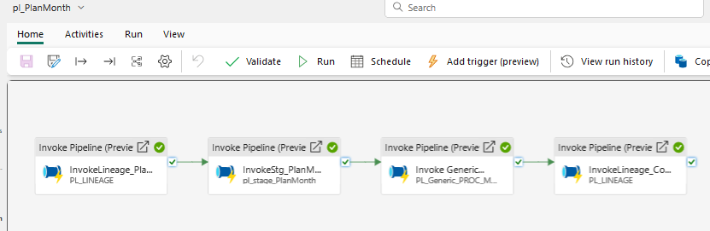

#### **Scheduling Options:**

* **Frequency:** Monthly (the 1st calendar day of the month)
* **Reprocessing and loading Logic:**
  + **Monthly:** The 1st calendar day of the Month, based on "fecha" field, reprocess the **Month To Date + Next 4 months** data.
* **Load type:** Delete and Insert, the **Month To Date + Next 4 months -** based on the "fecha" field.   
  **Note:** The historical data is required to be maintained (do not delete the historical records). The “Delete” is for the purpose of reprocessing, it requires to delete ONLY the **Month to Date + Next 4 months** period (previous/historical data should not be touched – deleted or changed).

#### **Field-Level Descriptions and Transformations – Gold Layer:**

* **plan_month_sk:**
  + **Target Field Name:** plan_month_sk
  + **Target Datatype:** BIGINT
  + **Transformation Logic:** Surrogate key, serving as the primary key for the table. A sequential or unique value is generated for each record during data insertion.
* **fecha_sk:**
  + **Target Field Name:** fecha_sk
  + **Target Datatype:** INT
  + **Transformation Logic:** Foreign key fetched from the dim_calendar table. The date format follows the pattern YYYYMMDD (e.g., 20241007).
* **lineage_sk:**
  + **Target Field Name:** lineage_sk
  + **Target Datatype:** INT
  + **Transformation Logic:** Foreign key retrieved from the log_lineage table to track run history.
* **horizonte_plan:**
  + **Target Field Name:** horizonte_plan
  + **Target Datatype:** CHAR(15)
  + **Transformation Logic:** Field remains unchanged from source to target.
* **fecha:**
  + **Target Field Name:** fecha
  + **Target Datatype:** DATE
  + **Transformation Logic:** Conversion applied to DATE.
* **gasto:**
  + **Target Field Name:** gasto
  + **Target Datatype:** VARCHAR(5)
  + **Transformation Logic:** Field remains unchanged from source to target.
* **material:**
  + **Target Field Name:** material
  + **Target Datatype:** VARCHAR(16)
  + **Transformation Logic:** Field remains unchanged from source to target.
* **zona:**
  + **Target Field Name:** zona
  + **Target Datatype:** VARCHAR(4)
  + **Transformation Logic:** Field remains unchanged from source to target.
* **tipo_actividad:**
  + **Target Field Name:** tipo_actividad
  + **Target Datatype:** VARCHAR(30)
  + **Transformation Logic:** Field remains unchanged from source to target.
* **metodo:**
  + **Target Field Name:** metodo
  + **Target Datatype:** VARCHAR(4)
  + **Transformation Logic:** Field remains unchanged from source to target.
* **equipo:**
  + **Target Field Name:** equipo
  + **Target Datatype:** VARCHAR(15)
  + **Transformation Logic:** Field remains unchanged from source to target.
* **tipo_de_obra:**
  + **Target Field Name:** tipo_de_obra
  + **Target Datatype:** VARCHAR(3)
  + **Transformation Logic:** Field remains unchanged from source to target.
* **nombre:**
  + **Target Field Name:** nombre
  + **Target Datatype:** VARCHAR(40)
  + **Transformation Logic:** Field remains unchanged from source to target.
* **m_metros:**
  + **Target Field Name:** m_metros
  + **Target Datatype:** DECIMAL(8,4)
  + **Transformation Logic:** Field remains unchanged from source to target.
* **toneladas:**
  + **Target Field Name:** toneladas
  + **Target Datatype:** DECIMAL(16,8)
  + **Transformation Logic:** Field remains unchanged from source to target.
* **dtm_grade_au_g_t:**
  + **Target Field Name:** dtm_grade_au_g_t
  + **Target Datatype:** DECIMAL(12,8)
  + **Transformation Logic:** Field remains unchanged from source to target.
* **dtm_grade_ag_g_t:**
  + **Target Field Name:** dtm_grade_ag_g_t
  + **Target Datatype:** DECIMAL(12,8)
  + **Transformation Logic:** Field remains unchanged from source to target.
* **dtm_grade_cu_%:**
  + **Target Field Name:** dtm_grade_cu_%
  + **Target Datatype:** DECIMAL(12,8)
  + **Transformation Logic:** Field remains unchanged from source to target.
* **dtm_grade_aueq_g_t:**
  + **Target Field Name:** dtm_grade_aueq_g_t
  + **Target Datatype:** DECIMAL(12,8)
  + **Transformation Logic:** Field remains unchanged from source to target.
* **in_grade_au_g_t:**
  + **Target Field Name:** in_grade_au_g_t
  + **Target Datatype:** DECIMAL(12,8)
  + **Transformation Logic:** Field remains unchanged from source to target.
* **in_grade_ag_g_t:**
  + **Target Field Name:** in_grade_ag_g_t
  + **Target Datatype:** DECIMAL(12,8)
  + **Transformation Logic:** Field remains unchanged from source to target.
* **in_grade_cu_%:**
* **Target Field Name:** in_grade_cu_%
* **Target Datatype:** DECIMAL(12,8)
* **Transformation Logic:** Field remains unchanged from source to target.
* **in_grade_aueq_g_t:**
  + **Target Field Name:** in_grade_aueq_g_t
  + **Target Datatype:** DECIMAL(12,8)
  + **Transformation Logic:** Field remains unchanged from source to target.
* **fe_%:**
  + **Target Field Name:** fe_%
  + **Target Datatype:** DECIMAL(17,14)
  + **Transformation Logic:** Field remains unchanged from source to target.
* **s_%:**
  + **Target Field Name:** s_%
  + **Target Datatype:** DECIMAL(17,14)
  + **Transformation Logic:** Field remains unchanged from source to target.

### PlanYearDB Source Excel File

#### **Source/target Information:**

* **Source File Name:** PlanYearDB.xlsx
* **Source File Location :** [https://torexgold.sharepoint.com/sites/MediaLunaProject/Technical Services/08_Reportes/01_Pruebas_BD/PlanYearDB.xlsx](https://torexgold.sharepoint.com/sites/MediaLunaProject/Technical%20Services/08_Reportes/01_Pruebas_BD/PlanYearDB.xlsx)
* **Staging Table Name (Silver Layer):** stg_plan_year
* **Target Table Name (Gold Layer):** fact_plan_year

#### **Table Description:**

This **Plan Year** file primarily records the annual budget data, including the date and location of the minerals, as well as type of material- whether it is gold, silver, copper, or another mineral. It also specifies whether the material is waste or ore, etc., providing key details about the composition and categorization of the extracted resources. The main purpose of this file is to support the annual budget planning.

#### **Key Information:**

* **Pipe Name:** [pl_PlanYear](https://app.fabric.microsoft.com/groups/225ef3c4-f1f6-4c57-87b5-b2a8216e7d46/pipelines/6ad3349d-acd9-4e64-83db-d399c8875f15?experience=data-engineering&subfolderId=21881) To load into fact_plan_year
* **Stage pipeline Name:** [pl_stage_PlanYearDB](https://app.fabric.microsoft.com/groups/225ef3c4-f1f6-4c57-87b5-b2a8216e7d46/pipelines/a3560011-35f0-4c64-8342-e9eefd56b24f?experience=data-engineering&subfolderId=21881) To load into stg_plan_year
* **Data flow Name:**  [df2_mml_brz_PlanYeardb](https://app.fabric.microsoft.com/groups/225ef3c4-f1f6-4c57-87b5-b2a8216e7d46/pipelines/6ad3349d-acd9-4e64-83db-d399c8875f15?experience=data-engineering&subfolderId=21881)

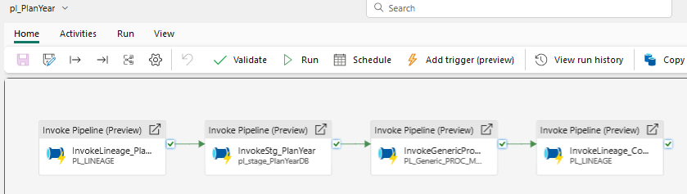

#### **Scheduling Options:**

* **Frequency:** Monthly, running the 1st calendar day of the month.
* **Reprocessing and loading Logic:**
  + **Monthly:** The 1st calendar day of the Month, based on "fecha" field, reprocess the **Month To Date + Remaining rest of the Year** data.
* **Load type:** Delete and Insert, the **Month To Date + Remaining rest of the Year -** based on the "fecha" field. **Note:** The historical data is required to be maintained (do not delete the historical records). The “Delete” is for the purpose of reprocessing, it requires to delete ONLY the **Month to Date + Remaining rest of the Year** period (previous/historical data should not be touched – deleted or changed).

#### **Field-Level Descriptions and Transformations – Gold Layer:**

* **plan_year_sk:**
  + **Target Field Name:** plan_year_sk
  + **Target Datatype:** BIGINT
  + **Transformation Logic:** Surrogate key, serving as the primary key for the table. A sequential or unique value is generated for each record during data insertion.
* **fecha_sk:**
  + **Target Field Name:** fecha_sk
  + **Target Datatype:** INT
  + **Transformation Logic:** Foreign key fetched from the dim_calendar table. The date format follows the pattern YYYYMMDD (e.g., 20241007).
* **lineage_sk:**
  + **Target Field Name:** lineage_sk
  + **Target Datatype:** INT
  + **Transformation Logic:** Foreign key retrieved from the log_lineage table to track run history.
* **fecha:**
  + **Target Field Name:** fecha
  + **Target Datatype:** DATE
  + **Transformation Logic:** Conversion applied to DATE.
* **gasto:**
  + **Target Field Name:** gasto
  + **Target Datatype:** VARCHAR(5)
  + **Transformation Logic:** Field remains unchanged from source to target.
* **material:**
  + **Target Field Name:** material
  + **Target Datatype:** VARCHAR(20)
  + **Transformation Logic:** Field remains unchanged from source to target.
* **zona:**
  + **Target Field Name:** zona
  + **Target Datatype:** VARCHAR(4)
* **tipo_actividad:**
  + **Target Field Name:** tipo_actividad
  + **Target Datatype:** VARCHAR(50)
  + **Transformation Logic:** Field remains unchanged from source to target.
* **metodo:**
  + **Target Field Name:** metodo
  + **Target Datatype:** VARCHAR(4)
  + **Transformation Logic:** Field remains unchanged from source to target.
* **equipo:**
  + **Target Field Name:** equipo
  + **Target Datatype:** VARCHAR(15)
  + **Transformation Logic:** Field remains unchanged from source to target.
* **nivel**
  + **Target Field Name:** nivel
  + **Target Datatype:** INT
  + **Transformation Logic:** Field remains unchanged from source to target.
* **tipo_de_obra:**
  + **Target Field Name:** tipo_de_obra
  + **Target Datatype:** VARCHAR(10)
  + **Transformation Logic:** Field remains unchanged from source to target.
* **nombre:**
  + **Target Field Name:** nombre
  + **Target Datatype:** VARCHAR(50)
  + **Transformation Logic:** Field remains unchanged from source to target.
* **y_metros:**
  + **Target Field Name:** y_metros
  + **Target Datatype:** DECIMAL(8,4)
  + **Transformation Logic:** Field remains unchanged from source to target.
* **toneladas:**
  + **Target Field Name:** toneladas
  + **Target Datatype:** DECIMAL(16,8)
  + **Transformation Logic:** Field remains unchanged from source to target.
* **modelo**
  + **Target Field Name:** modelo
  + **Target Datatype:** VARCHAR(20)
  + **Transformation Logic:** Field remains unchanged from source to target.
* **rqd_q:**
  + **Target Field Name:** rqd_q
  + **Target Datatype:** DECIMAL(20,14)
  + **Transformation Logic:** Field remains unchanged from source to target.
* **dtm_grade_au_g_t:**
  + **Target Field Name:** dtm_grade_au_g_t
  + **Target Datatype:** DECIMAL(12,8)
  + **Transformation Logic:** Field remains unchanged from source to target.
* **dtm_grade_ag_g_t:**
  + **Target Field Name:** dtm_grade_ag_g_t
  + **Target Datatype:** DECIMAL(12,8)
  + **Transformation Logic:** Field remains unchanged from source to target.
* **dtm_grade_cu_%:**
  + **Target Field Name:** dtm_grade_cu_%
  + **Target Datatype:** DECIMAL(12,8)
  + **Transformation Logic:** Field remains unchanged from source to target.
* **dtm_grade_aueq_g_t:**
  + **Target Field Name:** dtm_grade_aueq_g_t
  + **Target Datatype:** DECIMAL(12,8)
  + **Transformation Logic:** Field remains unchanged from source to target.

### Equipment Availability Source SQL Function

#### **Source/target Information:**

* **Source Table Name (SQL):** [BI].[EquipmentAvailability]
* **Fabric source Connection details :** MML_HexagonDB_SQL_Connection/ jmineops
* **Staging Table Name (Silver Layer):** stg_equipment_availability
* **Target Table Name (Gold Layer):** fact_equipment_availability

#### **Table Description:**

On this table we are filtering for the Fleet = 'UNDERGROUND' (flota = subterránea) for the **Media Luna Mining (MML)** operation (since this table also comprise of 'UNDERGROUND-ELG'). This table measures Dailythe Equipment Availability and Utilization. The data for reporting requires to be structured hierarchically by **Year > Quarter > Month > Week > Day**.

#### **Key Prompts in reports:**

* **Equipo (Equipment)**
* **Date**

#### **Key Information:**

* **Main pipeline Name:** [pl_Equipment_availability](https://app.fabric.microsoft.com/groups/225ef3c4-f1f6-4c57-87b5-b2a8216e7d46/pipelines/75b0bba0-df3d-49b4-92ee-8d996fe9d9e3?experience=data-engineering&subfolderId=22243)  to load into fact_equipment_availability
* **stage pipeline Name:** [pl_brz_ml_op_equipmentavailability](https://app.fabric.microsoft.com/groups/225ef3c4-f1f6-4c57-87b5-b2a8216e7d46/pipelines/ede099f9-b192-46d6-a1c0-e0bbf7502863?experience=data-engineering&subfolderId=22243)  to load into stg_equipment_availability

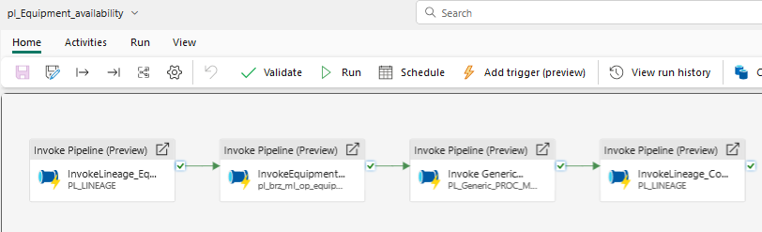

#### **Scheduling Options:**

* **Frequency:** Hourly & Daily
* **Reprocessing and loading Logic:**
  + **Hourly:** Based on the "time" and "Equipment" fields, reprocess the **Current date + Previous date** data.
  + **Daily:** Based on the "time" and "Equipment" fields, reprocess the **Current Week + Previous Week** data.
* **Load type:** Update and Insert (on both Hourly & Daily schedules): Verify if the data exists, based on the "time" and "Equipment" fields (key fields), then update; else insert (for example, insert if there is any new equipment on a particular date period).
* **Historical data:** Data is required to be loaded one-time since Jan 1, 2023. The historical data is required to be maintained (do not “update” the historical records). The update is required to be applied to the mentioned period - ONLY – depending on if hourly or daily (previous/historical data should not be touched – deleted or changed):
  + **Hourly**, would update ONLY**:** **Current date + Previous date** data.
  + **Daily**, would update ONLY **Current Week + Previous Week** data.

#### **Field-Level Descriptions and Transformations – Gold Layer:**

* **fact_equipment_availability_sk:**
  + **Target Field Name:** fact_equipment_availability_sk
  + **Target Datatype:** BIGINT
  + **Transformation Logic:** Surrogate key, serving as the primary key for the table. A sequential or unique value is generated for each record during data insertion.
* **time_sk:**
  + **Target Field Name:** time_sk
  + **Target Datatype:** INT
  + **Transformation Logic:** Foreign key fetched from the dim_calendar table. The date format follows the pattern YYYYMMDD (e.g., 20241007).
* **lineage_sk:**
  + **Target Field Name:** lineage_sk
  + **Target Datatype:** INT
  + **Transformation Logic:** Foreign key retrieved from the log_lineage table to track run history.
* **equipment_sk:**
  + **Target Field Name:** equipment_sk
  + **Target Datatype:** INT
  + **Transformation Logic:** Foreign key fetched from the dim_equipment table. This is based on a join between the staging table (stg_equipment_availability) and dim_equipment using both the equipment name and equipment type. (Reference: screenshot provided as a guide).
* **enum_sk:**
  + **Target Field Name:** enum_sk
  + **Target Datatype:** INT
  + **Transformation Logic:** Foreign key fetched from the dim_enum table, matching the unit field from the staging table (stg_equipment_availability) to the corresponding name field (unit) in dim_enum – where dim_enum.type = 'Unit'. (Reference: screenshot provided as a guide).
* **time:**
  + **Target Field Name:** time
  + **Target Datatype:** DATE
  + **Transformation Logic:** Conversion applied to DATE.
* **availability:**
  + **Target Field Name:** availability
  + **Target Datatype:** REAL
  + **Transformation Logic:** This field comes from the SQL source with the final availability calculation and is transferred unchanged from source to target.
* **utilization:**
  + **Target Field Name:** utilization
  + **Target Datatype:** REAL
  + **Transformation Logic:** This field comes from the SQL source with the final utilization calculation and is transferred unchanged from source to target.

### Equipment Source SQL Table

#### **Source/target Information:**

* **Source Connection details :** MML_HexagonDB_SQL_Connection/ jmineops
* **Source Table Name:** [dbo].[equipment]
* **Fabric Source Connection details :** MML_HexagonDB_SQL_Connection/ jmineops
* **Staging Table Name (Silver Layer):** stg_equipment
* **Target Table Name (Gold Layer):** dim_equipment

#### **Table Description:**

This table contains the details of Equipment associated with every fact_equipment_availability in a star schema. It includes key information such as equipment type, name, device ID, and various attributes required for tracking the availability and utilization of equipment in the Media Luna Mining operation.

#### **Key Information:**

* **Pipeline Name:** [pl_dim_Equipment](https://app.fabric.microsoft.com/groups/225ef3c4-f1f6-4c57-87b5-b2a8216e7d46/pipelines/f59b3b92-0ca2-45c2-a272-72b523afaa3d?experience=data-engineering&subfolderId=22140) to load into dim_equipment
* **Stage Pipeline Name:**  [[pl_brz_ml_dim_equipment](https://app.fabric.microsoft.com/groups/225ef3c4-f1f6-4c57-87b5-b2a8216e7d46/pipelines/28ebe222-d5e6-46aa-86cd-18be40fce09f?experience=data-engineering&subfolderId=22140)](https://app.fabric.microsoft.com/groups/225ef3c4-f1f6-4c57-87b5-b2a8216e7d46/pipelines/f59b3b92-0ca2-45c2-a272-72b523afaa3d?experience=data-engineering&subfolderId=22140) to load into stg_equipment

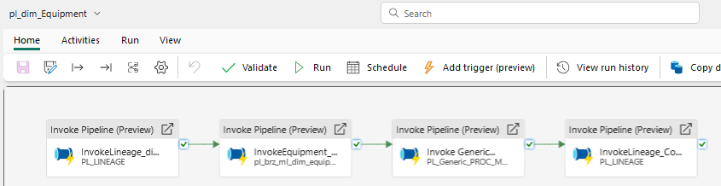

#### **Scheduling Options:**

* **Frequency:** Daily
* **Load type:** Slowly Changing Dimension type 1 (SCD1) – it would insert new records and update the whole dimension table.

#### **Field-Level Descriptions and Transformations – Gold Layer:**

* **equipment_sk:**
  + **Target Field Name:** equipment_sk
  + **Target Datatype:** INT
  + **Transformation Logic:** Surrogate key, serving as the primary key for the table. A sequential or unique value is generated for each record during data insertion.
* **lineage_sk:**
  + **Target Field Name:** lineage_sk
  + **Target Datatype:** INT
  + **Transformation Logic:** Foreign key retrieved from the log_lineage table to track run history.
* **id:**
  + **Target Field Name:** id
  + **Target Datatype:** INT
  + **Transformation Logic:** This field remains unchanged from source to target.
* **type:**
  + **Target Field Name:** type
  + **Target Datatype:** VARCHAR(60)
  + **Transformation Logic:** This field remains unchanged from source to target.
* **name:**
  + **Target Field Name:** name
  + **Target Datatype:** VARCHAR(60)
  + **Transformation Logic:** This field remains unchanged from source to target.
* **created_at:**
  + **Target Field Name:** created_at
  + **Target Datatype:** DATETIME2(6)
  + **Transformation Logic:** This field remains unchanged from source to target.
* **updated_at:**
  + **Target Field Name:** updated_at
  + **Target Datatype:** DATETIME2(6)
  + **Transformation Logic:** This field remains unchanged from source to target.
* **deleted_at:**
  + **Target Field Name:** deleted_at
  + **Target Datatype:** DATETIME2(6)
  + **Transformation Logic:** This field remains unchanged from source to target.
* **revision:**
  + **Target Field Name:** revision
  + **Target Datatype:** INT
  + **Transformation Logic:** This field remains unchanged from source to target.
* **device_id:**
  + **Target Field Name:** device_id
  + **Target Datatype:** INT
  + **Transformation Logic:** This field remains unchanged from source to target.
* **status_id:**
  + **Target Field Name:** status_id
  + **Target Datatype:** INT
  + **Transformation Logic:** This field remains unchanged from source to target.
* **reason_id:**
  + **Target Field Name:** reason_id
  + **Target Datatype:** INT
  + **Transformation Logic:** This field remains unchanged from source to target.
* **lineup_status_id:**
  + **Target Field Name:** lineup_status_id
  + **Target Datatype:** INT
  + **Transformation Logic:** This field remains unchanged from source to target.
* **lineup_reason_id:**
  + **Target Field Name:** lineup_reason_id
  + **Target Datatype:** INT
  + **Transformation Logic:** This field remains unchanged from source to target.
* **equipment_type_id:**
  + **Target Field Name:** equipment_type_id
  + **Target Datatype:** INT
  + **Transformation Logic:** This field remains unchanged from source to target.
* **activity_id:**
  + **Target Field Name:** activity_id
  + **Target Datatype:** INT
  + **Transformation Logic:** This field remains unchanged from source to target.
* **activity_start:**
  + **Target Field Name:** activity_start
  + **Target Datatype:** DATETIME2(6)
  + **Transformation Logic:** This field remains unchanged from source to target.
* **size:**
  + **Target Field Name:** size
  + **Target Datatype:** FLOAT
  + **Transformation Logic:** This field remains unchanged from source to target.
* **tiedown_id:**
  + **Target Field Name:** tiedown_id
  + **Target Datatype:** INT
  + **Transformation Logic:** This field remains unchanged from source to target.
* **unit_id:**
  + **Target Field Name:** unit_id
  + **Target Datatype:** INT
  + **Transformation Logic:** This field remains unchanged from source to target.
* **length:**
  + **Target Field Name:** length
  + **Target Datatype:** INT
  + **Transformation Logic:** This field remains unchanged from source to target.
* **height:**
  + **Target Field Name:** height
  + **Target Datatype:** INT
  + **Transformation Logic:** This field remains unchanged from source to target.
* **project_id:**
  + **Target Field Name:** project_id
  + **Target Datatype:** INT
  + **Transformation Logic:** This field remains unchanged from source to target.
* **time_Late:**
  + **Target Field Name:** time_Late
  + **Target Datatype:** DATETIME2(6)
  + **Transformation Logic:** This field remains unchanged from source to target.
* **prestart_check:**
  + **Target Field Name:** prestart_check
  + **Target Datatype:** SMALLINT
  + **Transformation Logic:** This field remains unchanged from source to target.
* **warnings:**
  + **Target Field Name:** warnings
  + **Target Datatype:** VARCHAR(8000)
  + **Transformation Logic:** This field remains unchanged from source to target.
* **hp_equipment_type_id:**
  + **Target Field Name:** hp_equipment_type_id
  + **Target Datatype:** INT
  + **Transformation Logic:** This field remains unchanged from source to target.
* **department_id:**
  + **Target Field Name:** department_id
  + **Target Datatype:** INT
  + **Transformation Logic:** This field remains unchanged from source to target.
* **lineup_comment:**
  + **Target Field Name:** lineup_comment
  + **Target Datatype:** VARCHAR(8000)
  + **Transformation Logic:** This field remains unchanged from source to target.
* **no_auto_accept:**
  + **Target Field Name:** no_auto_accept
  + **Target Datatype:** INT
  + **Transformation Logic:** This field remains unchanged from source to target.
* **contractor_id:**
  + **Target Field Name:** contractor_id
  + **Target Datatype:** INT
  + **Transformation Logic:** This field remains unchanged from source to target.
* **repair_status_id:**
  + **Target Field Name:** repair_status_id
  + **Target Datatype:** INT
  + **Transformation Logic:** This field remains unchanged from source to target.
* **weight:**
  + **Target Field Name:** weight
  + **Target Datatype:** REAL
  + **Transformation Logic:** This field remains unchanged from source to target.
* **lineup_priority_id:**
  + **Target Field Name:** lineup_priority_id
  + **Target Datatype:** INT
  + **Transformation Logic:** This field remains unchanged from source to target.
* **geometry_node_set_id:**
  + **Target Field Name:** geometry_node_set_id
  + **Target Datatype:** INT
  + **Transformation Logic:** This field remains unchanged from source to target.
* **geometry_param_set_id:**
  + **Target Field Name:** geometry_param_set_id
  + **Target Datatype:** INT
  + **Transformation Logic:** This field remains unchanged from source to target.
* **iconset_id:**
  + **Target Field Name:** iconset_ild
  + **Target Datatype:** INT
  + **Transformation Logic:** This field remains unchanged from source to target.
* **last_activity_id:**
  + **Target Field Name:** last_activity_id
  + **Target Datatype:** INT
  + **Transformation Logic:** This field remains unchanged from source to target.

### Enum Table Source SQL Table

#### **Source/target Information:**

* **Source Table Name:** [dbo].[enum_tables]
* **Fabric Source Connection details :** MML_HexagonDB_SQL_Connection/ jmineops
* **Staging Table Name (Silver Layer):** stg_enum
* **Target Table Name (Gold Layer):** dim_enum

#### **Table Description:**

This table contains parameter information (for equipment and other related subjects) associated with every fact_equipment_availability in a star schema. It stores the attributes that can be referenced across various fact tables for standardized parameter lookups.

#### **Key Information:**

* **Pipeline Name:** [pl_enum](https://app.fabric.microsoft.com/groups/225ef3c4-f1f6-4c57-87b5-b2a8216e7d46/pipelines/509bde96-31b4-48a6-9efe-8100d45ca3b3?experience=data-engineering&subfolderId=22070) To load into dim_enum
* **Stage Pipeline Name:** [pl_brz_ml_stage_enum_tables](https://app.fabric.microsoft.com/groups/225ef3c4-f1f6-4c57-87b5-b2a8216e7d46/pipelines/93032ff6-a6c5-46e4-882f-f2587bbaf658?experience=data-engineering&subfolderId=22070)  to load into stg_enum

#### **Scheduling Options:**

* **Frequency:** Daily
* **Load type:** Slowly Changing Dimension type 1 (SCD1) – it would insert new records and update the whole dimension table.

#### **Field-Level Descriptions and Transformations – Gold Layer:**

* **enum_sk**
  + **Target Field Name:** enum_sk
  + **Target Datatype:** INT
  + **Transformation Logic:** Surrogate key serving as the primary key for the table. A sequential or unique value is generated for each record during data insertion.
* **lineage_sk**
  + **Target Field Name:** lineage_sk
  + **Target Datatype:** INT
  + **Transformation Logic:** Foreign key retrieved from the log_lineage table to track run history.
* **id**
  + **Target Field Name:** id
  + **Target Datatype:** INT
  + **Transformation Logic:** This field remains unchanged from source to target.
* **updated_at**
  + **Target Field Name:** updated_at
  + **Target Datatype:** DATETIME2(6)
  + **Transformation Logic:** This field remains unchanged from source to target.
* **type**
  + **Target Field Name:** type
  + **Target Datatype:** VARCHAR(60)
  + **Transformation Logic:** This field remains unchanged from source to target.
* **name**
  + **Target Field Name:** name
  + **Target Datatype:** VARCHAR(100)
  + **Transformation Logic:** This field remains unchanged from source to target.
* **symbol**
  + **Target Field Name:** symbol
  + **Target Datatype:** VARCHAR(60)
  + **Transformation Logic:** This field remains unchanged from source to target.
* **attributes**
  + **Target Field Name:** attributes
  + **Target Datatype:** INT
  + **Transformation Logic:** This field remains unchanged from source to target.
* **ordinal**
  + **Target Field Name:** ordinal
  + **Target Datatype:** INT
  + **Transformation Logic:** This field remains unchanged from source to target.
* **deleted_at**
  + **Target Field Name:** deleted_at
  + **Target Datatype:** DATETIME2(6)
  + **Transformation Logic:** This field remains unchanged from source to target.

### Calendar Dimension

#### **Source/target Information:**

* **Source Table Name:** N/A
* **Staging Table Name:** N/A
* **Target Table Name (Gold Layer):** dim_calendar

#### **Table Description:**

The time dimension table is associated with every fact table in a star schema. It contains various time-based attributes such as year, quarter, month, week, and day. It is an essential dimension used for time-based analysis across facts. If it’s the first week of January of the current year, the corresponding year will be inserted.

#### **Key Information:**

* **Script Name:** TBD

#### **Load type:**

* **Type:** Slowly Changing Dimension type 0 (SCD0) – no updates required.

#### **Field-Level Descriptions and Transformations – Gold Layer:**

* **calendar_sk**
  + **Target Field Name:** calendar_sk
  + **Target Datatype:** INT
  + **Transformation Logic:** A date value in YYYYMMDD format.
  + **Target Sample:** 20240823
* **year**
  + **Target Field Name:** year
  + **Target Datatype:** SMALLINT
  + **Transformation Logic:** The year of the date, in YYYY format.
  + **Target Sample:** 2024
* **half_code**
  + **Target Field Name:** half_code
  + **Target Datatype:** INT
  + **Transformation Logic:** A code representing the half of the year in YYYYHH format, where HH represents the half of the year (1 or 2).
  + **Target Sample:** 202402
* **half_descr**
  + **Target Field Name:** half_descr
  + **Target Datatype:** CHAR(7)
  + **Transformation Logic:** A descriptive label for the half-year in HH-YYYY format.
  + **Target Sample:** H2-2024
* **quarter_code**
  + **Target Field Name:** quarter_code
  + **Target Datatype:** INT
  + **Transformation Logic:** A code representing the quarter of the year in YYYYQQ format.
  + **Target Sample:** 202403
* **quarter_descr**
  + **Target Field Name:** quarter_descr
  + **Target Datatype:** CHAR(7)
  + **Transformation Logic:** A descriptive label for the quarter, using the format "Q" + CHAR(Quarter number) + "-" + CHAR(Year(DATE)).
  + **Target Sample:** Q3-2024
* **month_code**
  + **Target Field Name:** month_code
  + **Target Datatype:** INT
  + **Transformation Logic:** Year multiplied by 100, plus the month number in YYYYMM format.
  + **Target Sample:** 202408
* **month_descr**
  + **Target Field Name:** month_descr
  + **Target Datatype:** CHAR(8)
  + **Transformation Logic:** A descriptive label for the month, using the format Left(MonthName(Date), 3) + "-" + CHAR(Year(DATE)).
  + **Target Sample:** Aug-2024
* **weekday_code**
  + **Target Field Name:** weekday_code
  + **Target Datatype:** SMALLINT
  + **Transformation Logic:** Weekday number corresponding to the date.
  + **Target Sample:** 6
* **weekday_descr**
  + **Target Field Name:** Weekday_descr
  + **Target Datatype:** VARCHAR(9)
  + **Transformation Logic:** A descriptive label for the weekday, e.g., Weekday(Date).
  + **Target Sample:** Friday
* **weekmonth_code**
  + **Target Field Name:** weekmonth_code
  + **Target Datatype:** SMALLINT
  + **Transformation Logic:** A code representing the week of the month, calculated as Month Number*100 + Week of the Month Number(DATE).
  + **Target Sample:** 801
* **weekmonth_descr**
  + **Target Field Name:** weekmonth_descr
  + **Target Datatype:** CHAR(6)
  + **Transformation Logic:** A descriptive label for the week of the month, using the format Left(MonthName(Date), 3) + "-W" + CHAR(Week of the Month Number(DATE)).
  + **Target Sample:** Aug-W1
* **date**
  + **Target Field Name:** date
  + **Target Datatype:** DATE
  + **Transformation Logic:** Date remains unchanged.

## Assumptions

* The data sources will be available and accessible at the scheduled times.
* The Excel files’ column names or Excel file structure would be frozen of any changes.
* The transformation logic will be implemented as per the defined requirements.
* Any dataset not requiring transformation will be represented in Silver layer as a shortcut to Bronze to allow future transformations in Silver layer.
* A maximum of 2 Semantic Models would be developed based on the transformed data - one semantic model for all 5 Excel files and another semantic model for all 3 SQL Server tables.
* The Semantic Model/s will use snake case for tables and columns – instead of the column names as it is in the Excel files (per discussed on Nov/6 meeting).
* The reporting solution/s will be developed by Torex Gold.

## Key Success Criteria - for the MML solution

* Accurate and consistent data transformation.
* timely availability of data for insights.

## MML Scripts and Queries

**Dev ops GIT Link** : https://dev.azure.com/TRX-DWH-DevOps-Org/TRX-DWH-PRJ/_git/TXG-WS-DI-REP









## MML test plan and test cases

[Torex MML Test Plan & Tracker.xlsx](https://kyndryl.sharepoint.com/:x:/r/sites/ISMCAnalytics/_layouts/15/doc2.aspx?sourcedoc=%7B639bc20b-a9e7-4a54-9f6e-6774c858dc96%7D&action=edit&activeCell=%27SIT02%27!K7&wdinitialsession=88096659-676e-c61c-d388-d20d7a39b17b&wdrldsc=12&wdrldc=1&wdrldr=AccessTokenExpiredWarningGatekeeperCookieMismatch%2C)

[Torex MML Test Plan & Tracker v1.0.xlsx](https://torexgold.sharepoint.com/:x:/r/sites/TXG-GRP-DWH-PRJ/_layouts/15/doc2.aspx?sourcedoc=%7B94859342-4C14-4408-AF3D-F965F82B2D42%7D&file=Torex%20MML%20Test%20Plan%20&%20Tracker%20v1.0.xlsx=&action=default&mobileredirect=true)

## MML Deployment :

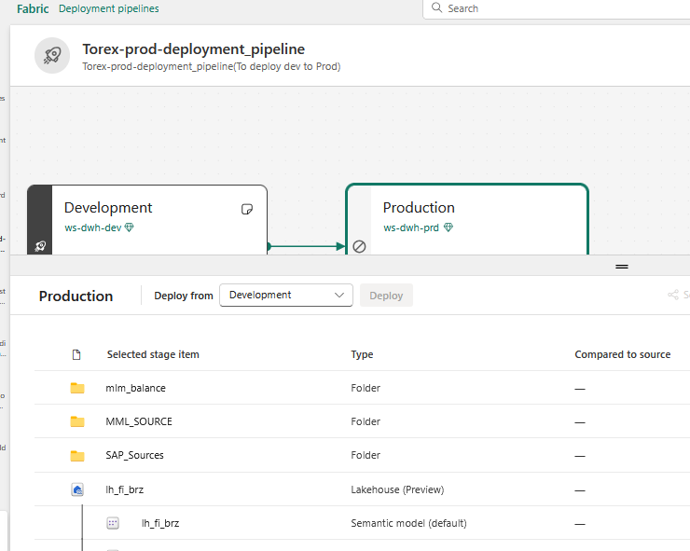

* Select stage item from development(Pipleine, lakehouse and warehouse etc)
* Click on deployment to move change from Dev to Prod

# Approvals

|  |  |  |
| --- | --- | --- |
|  |  |  |
| Name, Position |  | Date |

# Appendices

## Annex 1: Data Architecture

This diagram presents the data architecture that supports the MML solution:

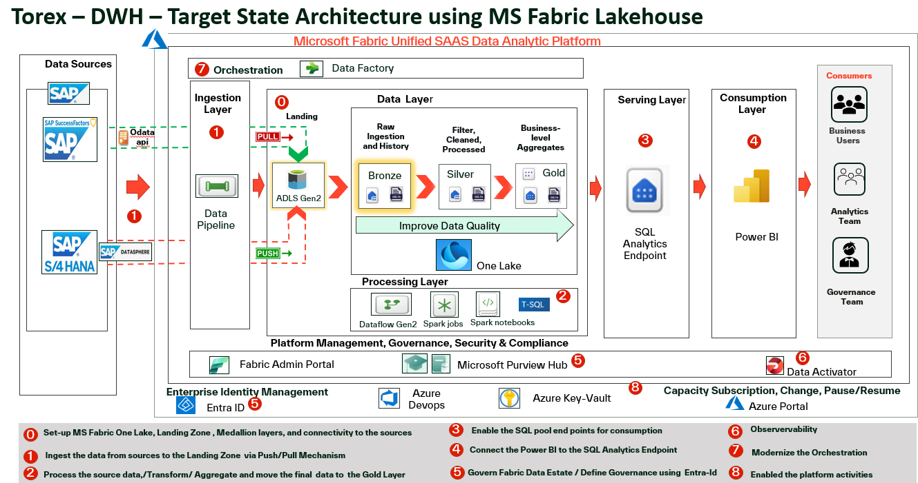

## Annex 2: DWH-End to End Implementation:

